**Online Certification Course**

**Name : Priya H T**

**Usn : 4AL17CS066**

**Course : Machine Learning with Python**

**Link** : <https://cognitiveclass.ai/courses>

**Cognitive class: ML0101ENv3**

**Orgn by: IBM**

**Start date:18/05/2020**

**Duration :10hrs**

**18/05/2020**

**Topic completed:**

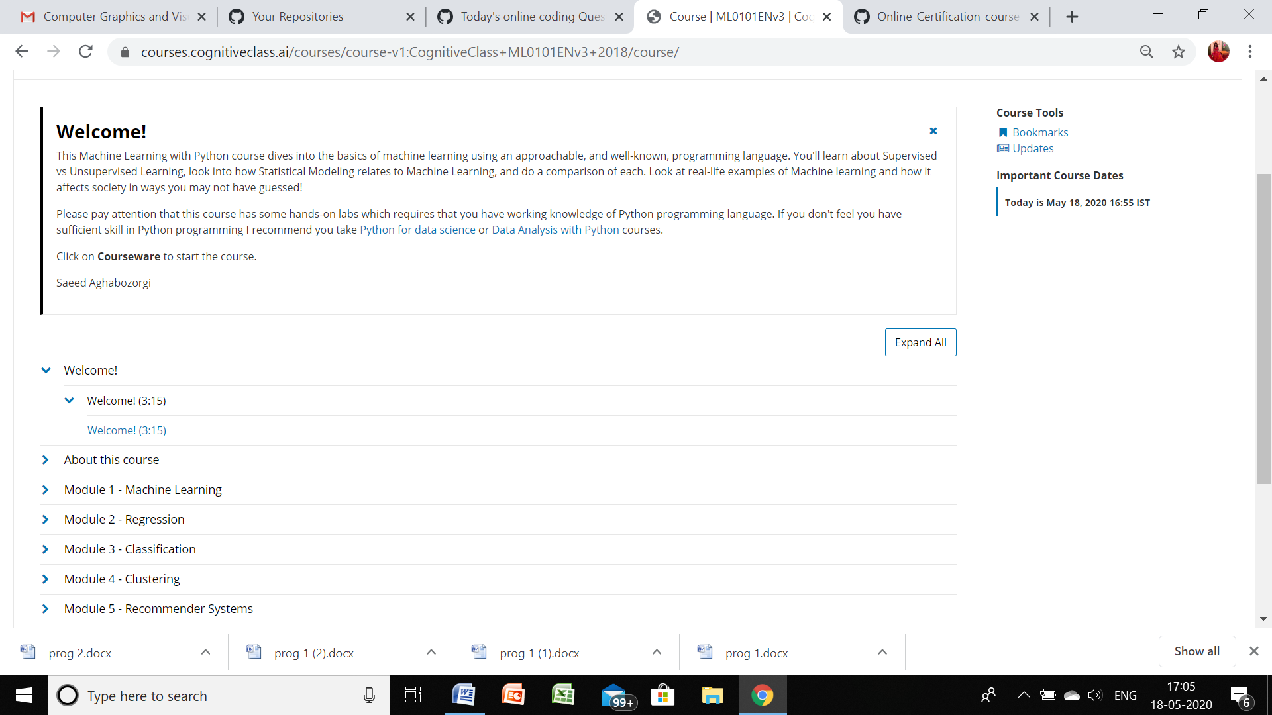

**Progress of today:**

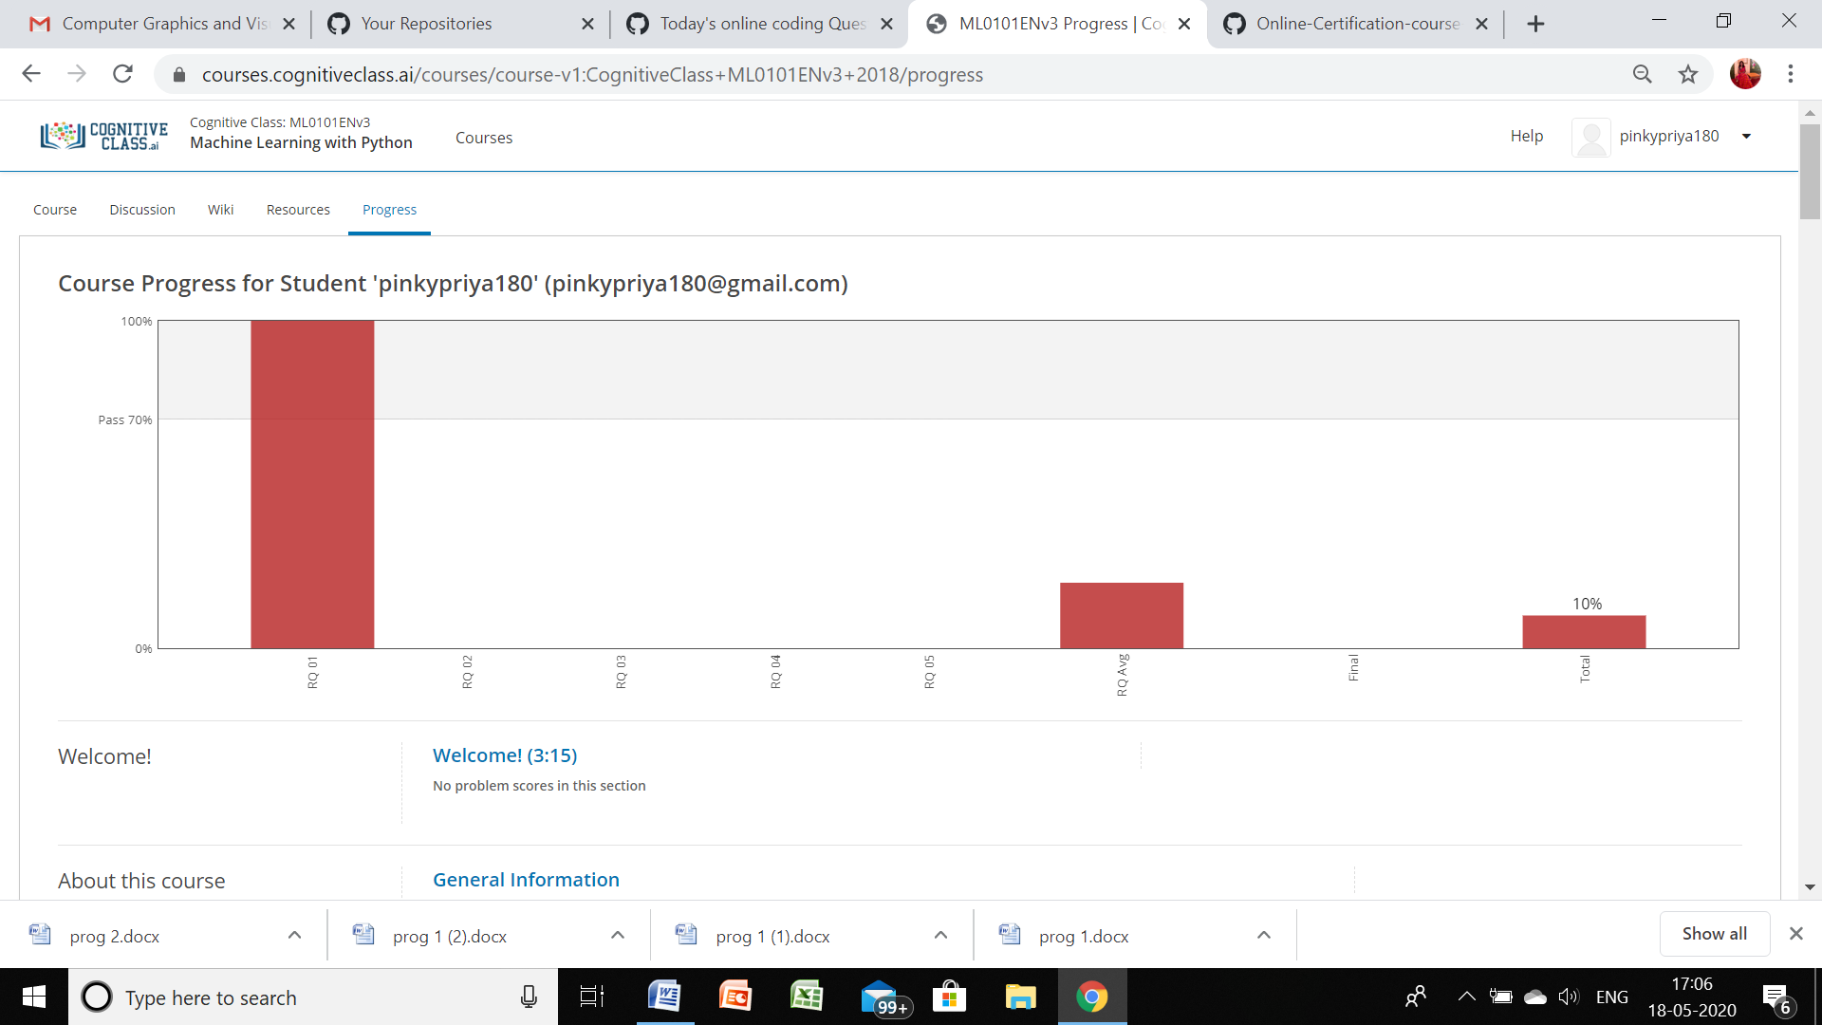

**19/05/2020**

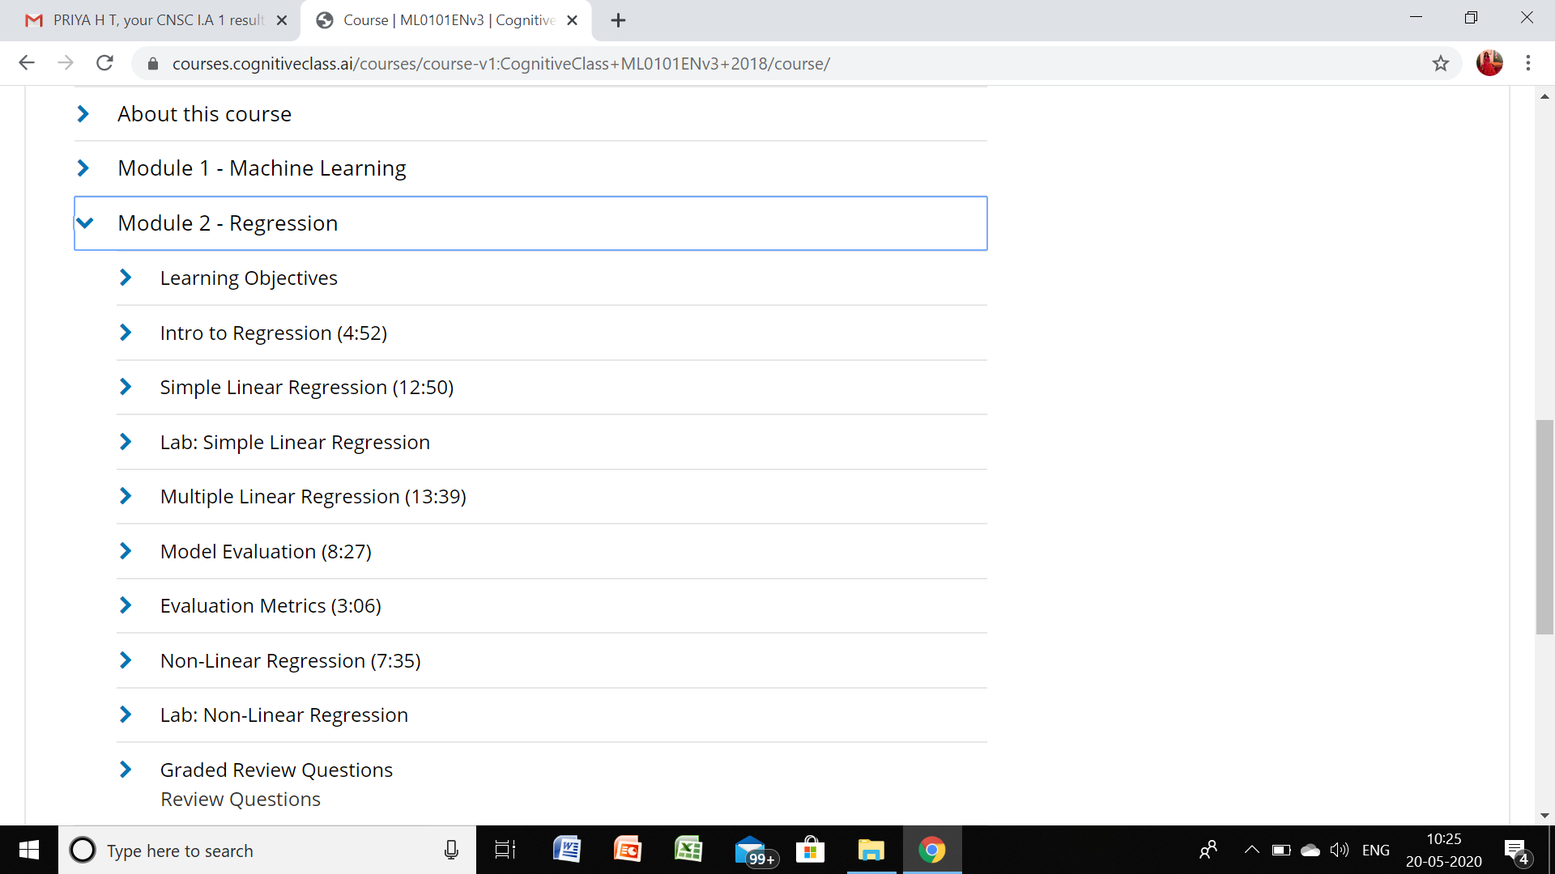

**Progress**

